Product Inventory Management System

Team topic:
Product Inventory Management System using Node.js,Express.js,and MongoDB.

Team Leader: L.Preethi(24bsccs08@cttewc.edu.in)

Team Members:-
Team Member Name: T. Kaliswari
Mail id: 24bsccs02@cttewc.edu.in
Team Member Name: D. Sandhiya
Mail id: 24bsccs04@cttewc.edu.in
Team Member Name: A.H. Lincy
Mail id: 24bsccs28@cttewc.edu.in

1️. Project Objective:-
The main objective of the Product Inventory Management System is to develop a backend application that helps in managing product details efficiently.
This system allows users to:
- Store product information in the database
- Update product details when required
- Track available products in the inventory
- Delete products that are no longer available
- This project helps students understand important backend development concepts such as REST API development, database integration, authentication, and server-side programming.

2️. Project Description:-
The Product Inventory Management System is a RESTful backend application developed using Node.js and Express.js.
This system provides an API through which users can perform CRUD operations (Create, Read, Update, Delete) on product data stored in a MongoDB database.
The application also implements JWT (JSON Web Token) authentication to ensure that only authorized users can access and manage product data.
API requests are tested using Thunder Client inside Visual Studio Code.

3️. Technologies Used:-
The following technologies are used in this project:
- Node.js:
JavaScript runtime used for backend development
- Express.js:
Web framework used to build REST APIs
- MongoDB:
NoSQL database used to store product and user data
- JWT Authentication:
Used for secure user authentication
- Thunder Client:
API testing tool in VS Code
- GitHub:
Version control and project repository.

4️.System Architecture:-
The system follows a Client-Server Architecture.
Components
1. Client
The client sends API requests to the server.
Thunder Client is used to test these API requests.
2. Server
Built using Node.js and Express.js.
Handles request processing, authentication, and routing.
3. Database
MongoDB stores all the user and product data.
System Flow
User → API Request → Server → Database → Server Response → Client.

5️.Database Schema:-
The database contains two main collections:
User Collection
Stores user information for authentication.
Fields:
Name – Name of the user
Email – User email address
Password – Encrypted password
Product Collection
Stores product details in the inventory.
Fields:
Product Name – Name of the product
Price – Product price
Quantity – Available product quantity
Description – Details about the product.

6️. API Endpoints:-
The system provides the following API endpoints:
Register User
POST /register
Creates a new user account.
Example Request:
Copy code

{
"name": "Preethi",
"email": "preethi@gmail.com",
"password": "123456"
}
Login User
POST /login
Authenticates the user and returns a JWT token.
Example Request:
Copy code

{
"email": "preethi@gmail.com",
"password": "123456"
}
Add Product
POST /products
Adds a new product to the inventory.
Example Request:
Copy code

{
"productName": "Laptop",
"price": 50000,
"quantity": 5,
"description": "Dell Laptop"
}
Get All Products
GET /products
Retrieves all the products stored in the inventory.
Update Product
PUT /products/:id
Updates product details using product ID.
Delete Product
DELETE /products/:id
Deletes a product from the inventory.

7️.Output Screenshots:-

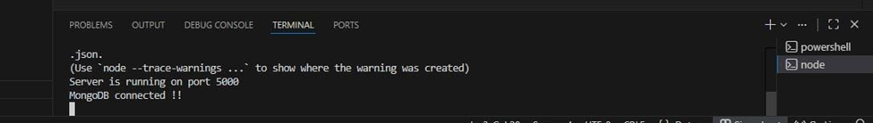

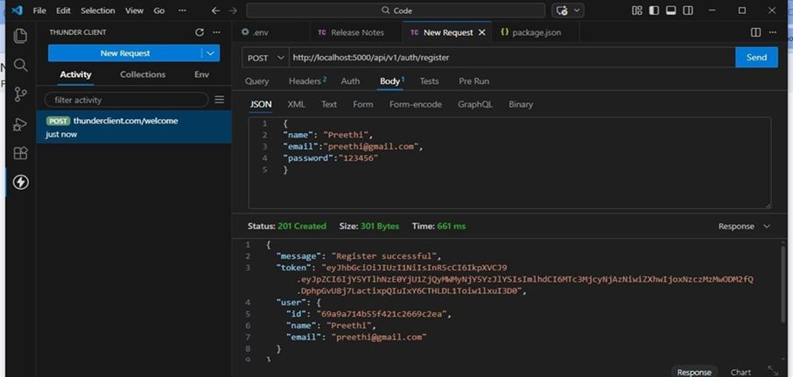
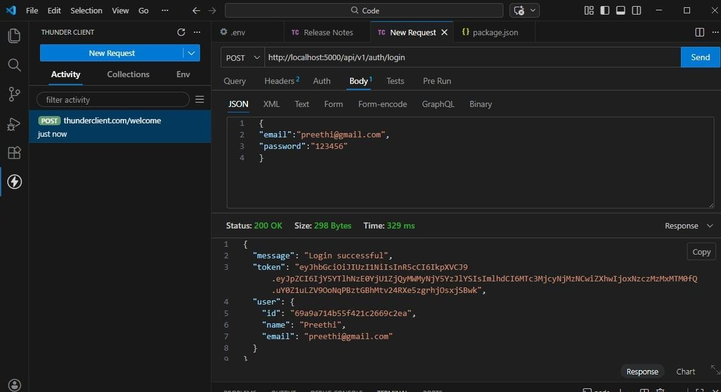
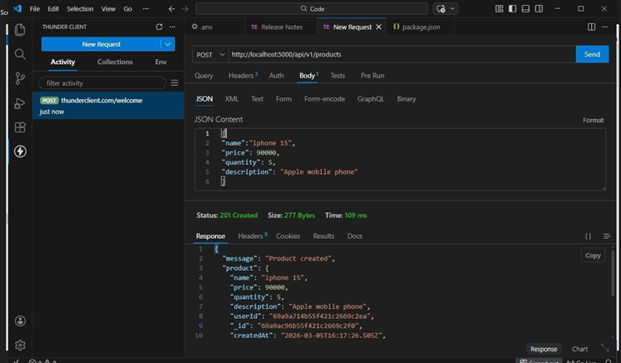

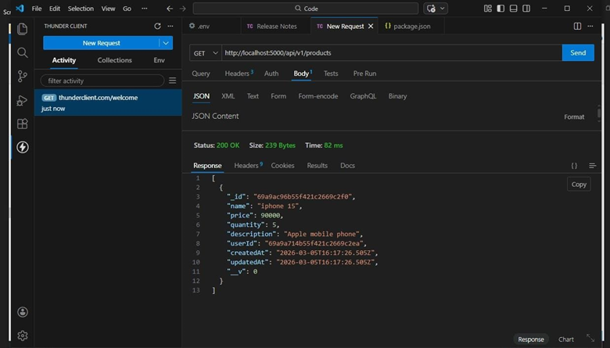
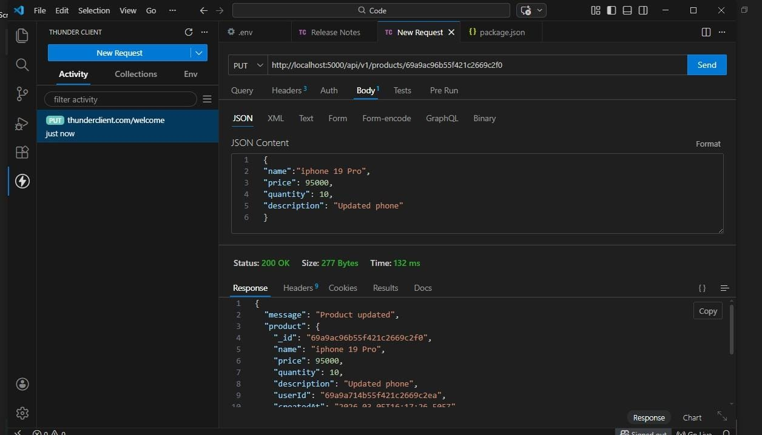

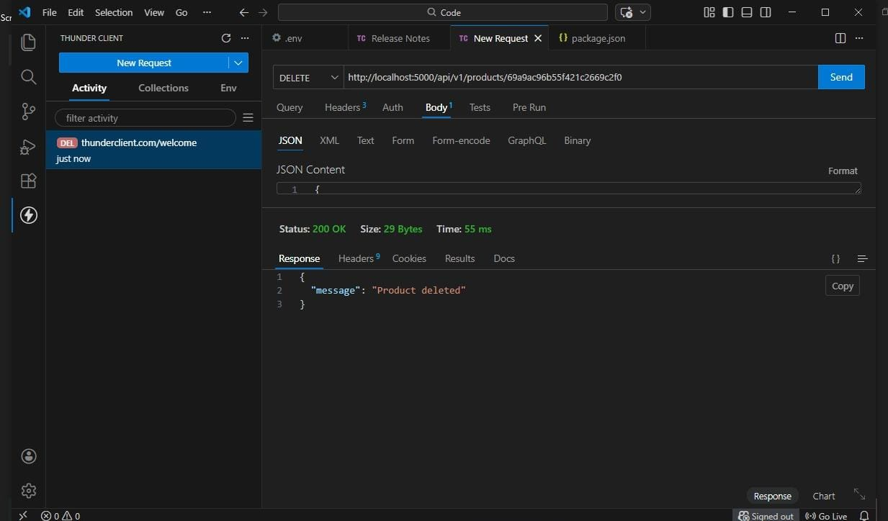

8️.Demo Video:-
https://drive.google.com/file/d/1NWBH8JdBs9gMlGkg0cqHdbyjpyW-yenu/view?usp=drivesdk

9️. Future Enhancements:-
- The following improvements can be implemented in the future:
- Developing a frontend interface using React.js
- Adding product search functionality
- Adding product category management
- Implementing inventory stock alerts
- Creating an admin dashboard for product management

10.Conclusion:-
The Product Inventory Management System provides a simple and efficient way to manage product inventory data using a backend API.
This project demonstrates key backend concepts such as:
REST API development
Database management using MongoDB
User authentication with JWT
CRUD operations
Overall, this project helps in improving knowledge of backend development, API design, and database integration.

